**Question:**

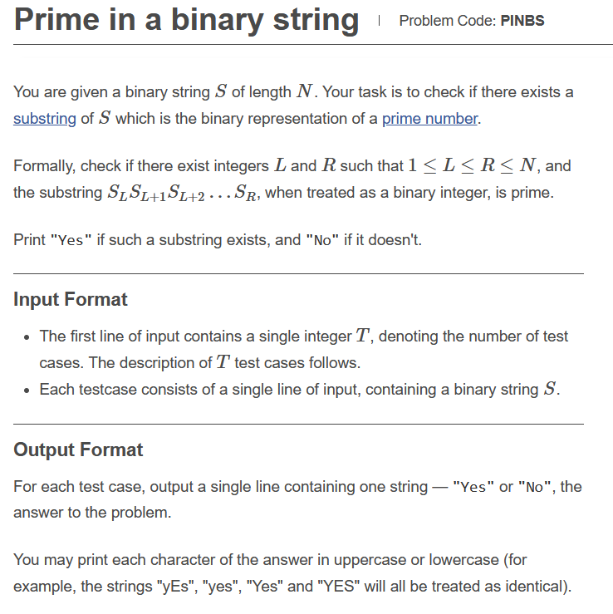

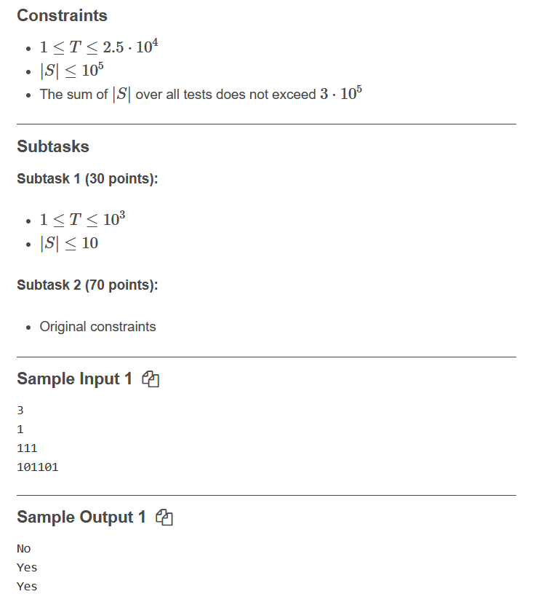

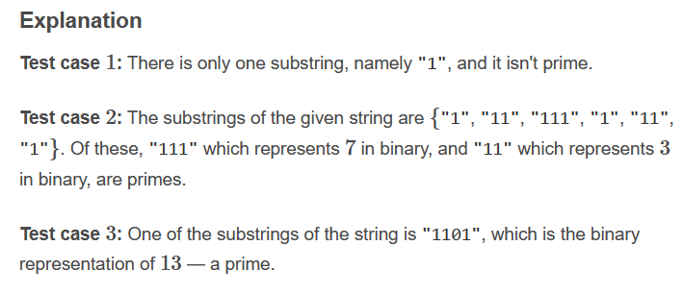

**Link:** [**https://www.codechef.com/JAN221C/problems/PINBS**](https://www.codechef.com/JAN221C/problems/PINBS)

**Code:**

**#include<bits/stdc++.h>**

**using namespace std;**

**int main()**

**{**

**int input;**

**cin>>input;**

**string str1,str2="10",str3="11";**

**for(int i=0;i<input;i++)**

**{**

**cin>>str1;**

**if (str1.find(str2) != string::npos) {**

**cout<<"yes"<<endl;**

**}**

**else if(str1.find(str3) != string::npos)**

**{**

**cout << "yes"<< endl;**

**}**

**else**

**{**

**cout<<"no" << endl;**

**}**

**}**

**return 0;**

**}**

**Solution: Correct(100 point)**